Data Structures Project

BY: Shaikh Waqar Mansoor,Sarim Khurram,Waleed Riasat
1. Overview
The project tries to mimic a decentralized storage network such as IPFS. In a typical web setup, if the central server goes down, data can be lost. In our mock setup, data is distributed over many machines arranged in a dynamic ring. We employed the Chord Protocol so that we can locate any file efficiently-in O(log N) time-without a centralized guide.

2. Code Logic

We kept things simple with three layers:
Data Storage, Machine, and Ring.
Layer 1: The Data Storage
- Each machine has to maintain the files locally. We implemented this using a Binary Search Tree (BST) with Linked Lists.
- Universal Hashing: We aren't storing the files by name, such as "movie.mp4." Every filename is transformed into a unique 32-bit ID with a hashing method. This lets machines handle data in a mathematical fashion.

Collision Handling: In case two different files end up with the same ID, we don't overwrite anything. We store both the files safely using a Linked List at that node.
Dynamic Extraction: A salient characteristic is “packing up” information. If a machine goes away, it does not vanish; all its files get moved to its neighbor.
Layer 2: Machine

- Every node is an instance of a class Machine.
- Identity: Each machine has a unique ID that fixes its place in the ring.
- Finger Table: The address book of the machine. If the machine knew only its neighbors, a file far away would be slow to find (linear time). So each machine maintains a Routing Table or Finger Table with shortcuts to other machines at exponentially growing distances, (2^0, 2^1, 2^2, .). This enables searches to skip big parts of the ring.
Layer 3: Ring
- Machines connect to form the Chord Ring.
- Self-Healing Topology: The network isn't fixed.
- Joining: A new machine incorporates itself in the sorted ring, connects to the neighbors, and requests data that will be handled by itself thereafter (data migration).
- Leaving: When a machine leaves it passes its data to its successor, before disconnecting the connection.

- Efficient Routing - Jump Logic: The guiding principle here is how we route the searches. In searching for a file:

- We do not just pass to the next neighbor.

- We begin the search backwards, starting with the farthest possible jump in the Finger Table.
- - Why backwards? Jumping to the largest distances first helps cover more ground in one step, moving towards the target without overshooting.

3. Logic & Implementation Notes

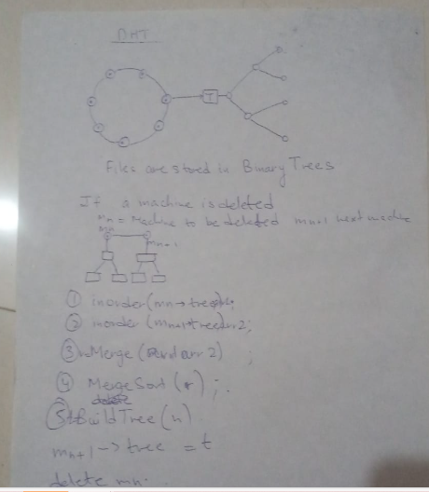
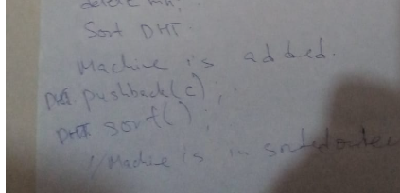
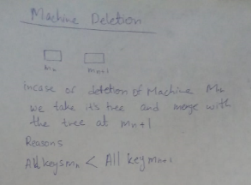
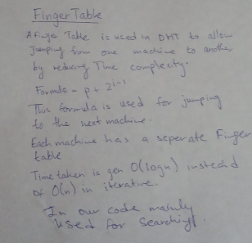

4. Demo

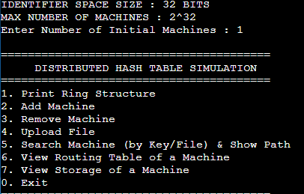
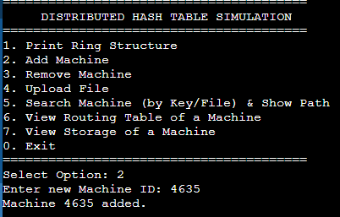
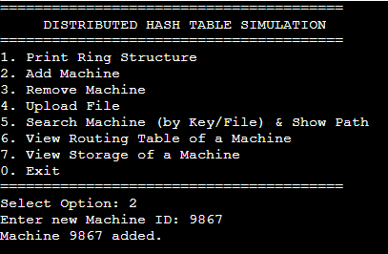
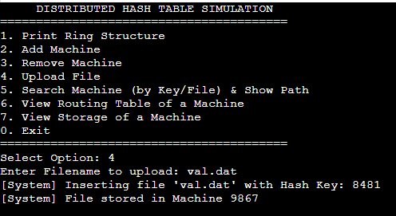
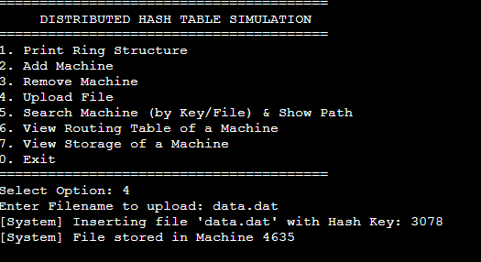
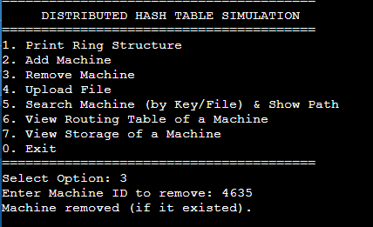

5. Conclusion:
The following simulation shows how decentralized systems work. By using a DHT, we show a storage network that is:
- Scalable: Search times remain low while the network grows.
- Robust: Data is safe when nodes join or leave the system.
- Efficient: Shortcuts reduce network traffic. This project serves as a working proof of concept for the technology behind contemporary decentralized storage networks like IPFS and BitTorrent.

